Practical 1: Basics of Image Processing
1(A) Image Representation
Aim: To understand practical implementation of Image Representation
Software Used: Jupyter Notebook
Theory: Image representation means showing an image in a form that a computer can understand and process. A digital image is made up of many small tiny squares called pixels. Each pixel stores a number that tells how bright or dark it is.
In a grayscale image, each pixel has only one value for brightness. In a color image, each pixel has three values that represent Red, Green, and Blue (RGB). These numbers together form the complete image.
By representing images as numbers, computers can easily store, modify, and analyze them. This helps in tasks like improving image quality, detecting objects, and compressing images.
Implementation & Result:
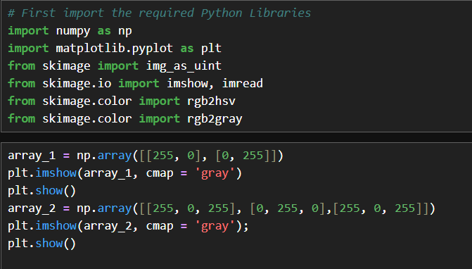

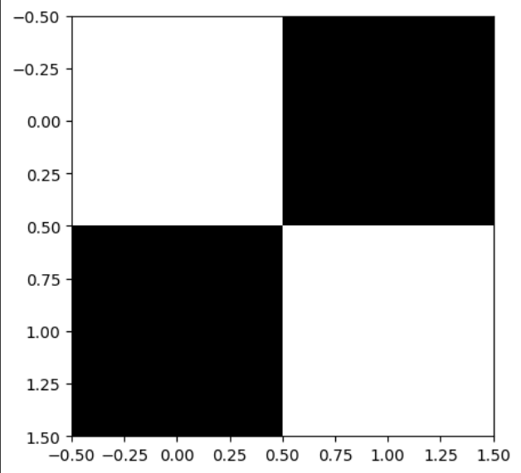
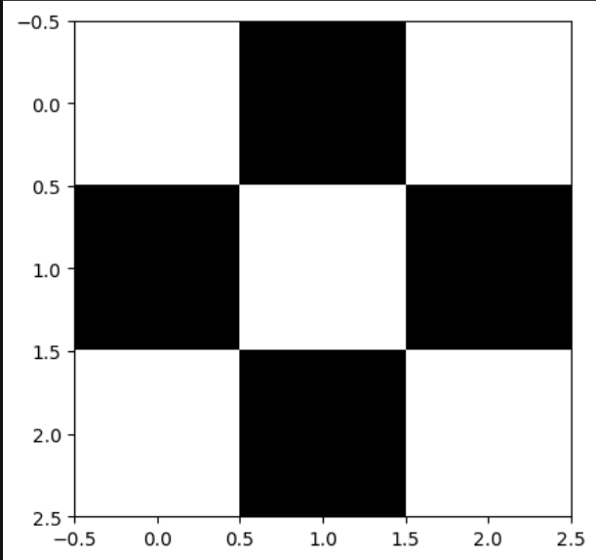

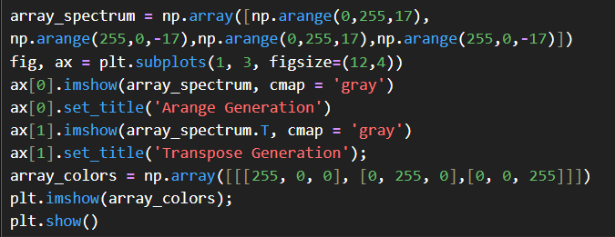
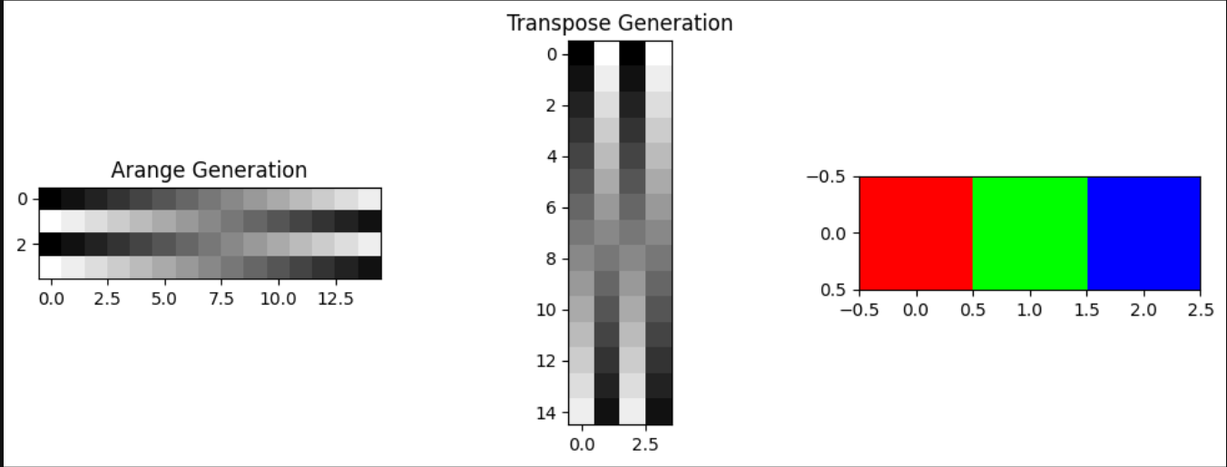

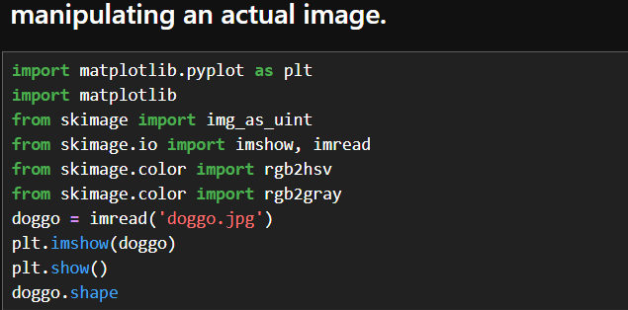
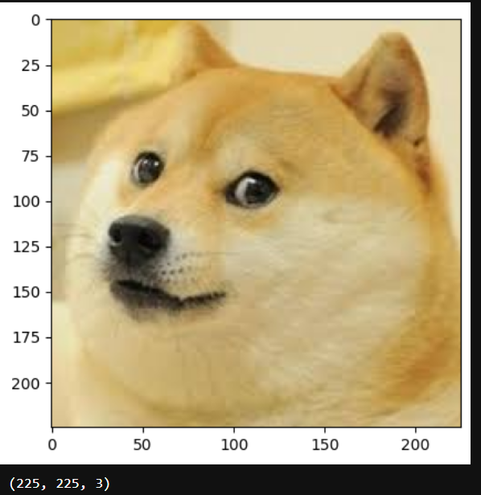
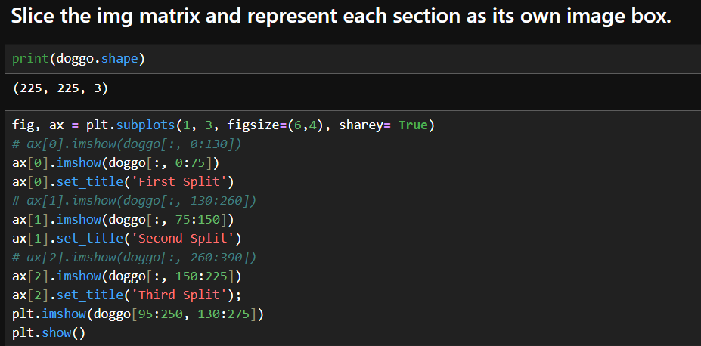
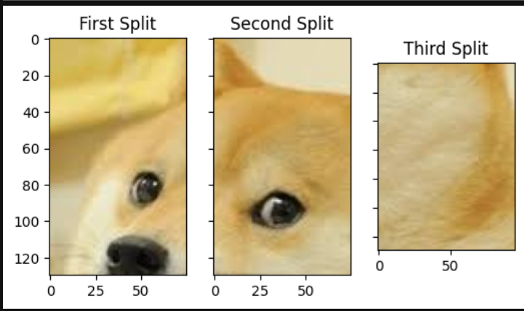
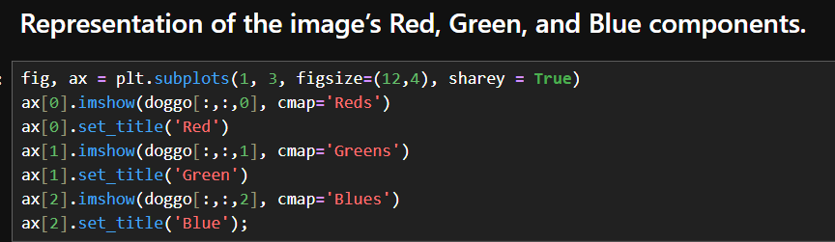
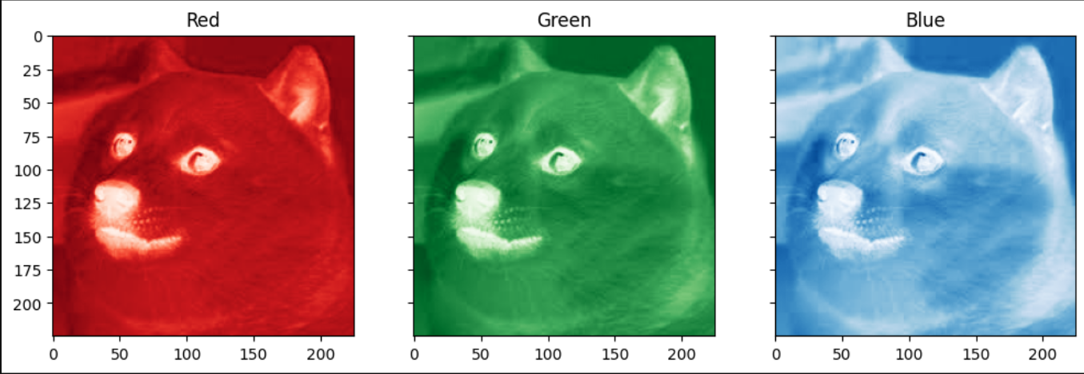
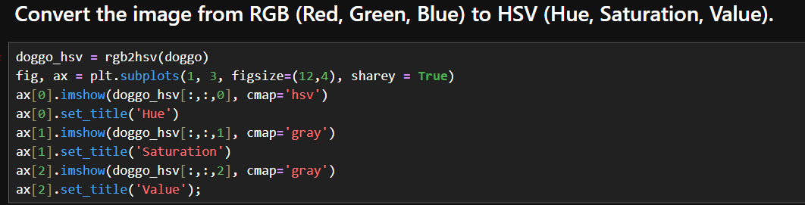
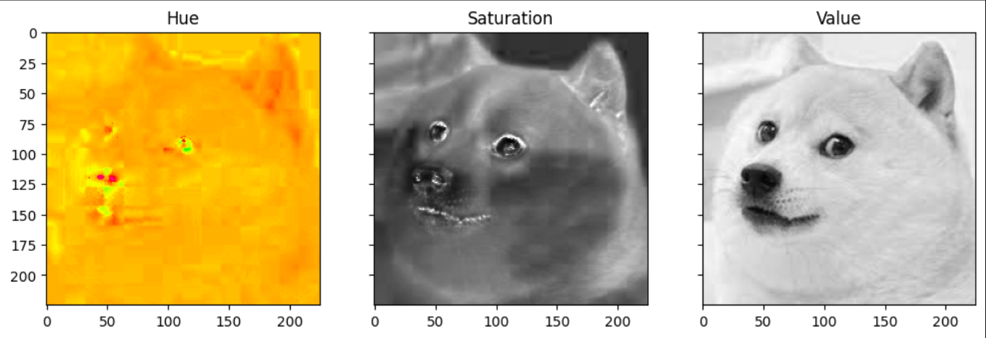
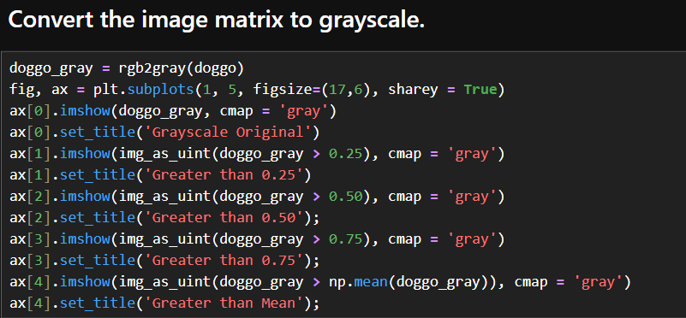

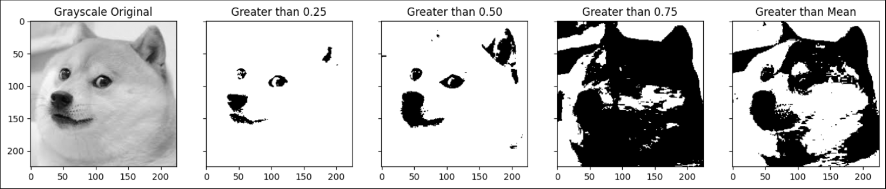

Conclusion: In conclusion, image representation is the process of converting an image into a digital form using pixels and numerical values. This allows computers to store, process, and analyze images easily, forming the basic foundation of all image processing operations.

1B) Sampling & Quantization
Aim: To convert a continuous image into a digital image using sampling and quantization.
Software Used: Jupyter Notebook
Theory: Sampling and quantization are the two main steps used to convert a continuous image into a digital image. Sampling refers to dividing the image into small, equally spaced points called pixels. It determines the spatial resolution of the image. Higher sampling means more pixels and better image detail, while lower sampling reduces quality.
Quantization refers to assigning a fixed number of intensity levels to each pixel. It converts continuous brightness values into discrete numerical values. More quantization levels produce smoother and clearer images, while fewer levels may cause loss of detail.
Together, sampling and quantization help represent images in digital form so they can be stored, processed, and analyzed by computers.
Implementation & Result:
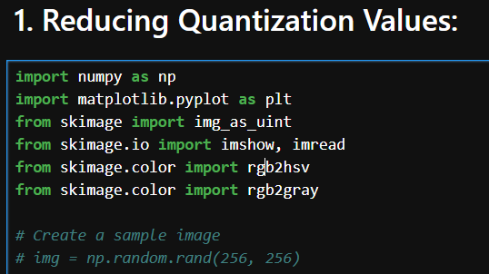
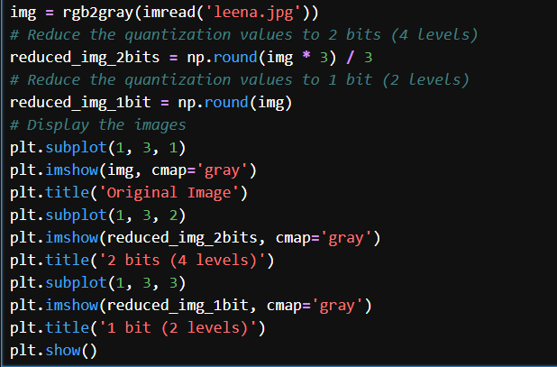
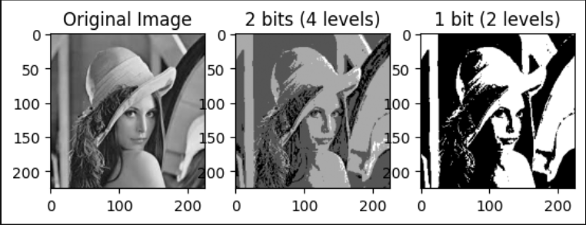
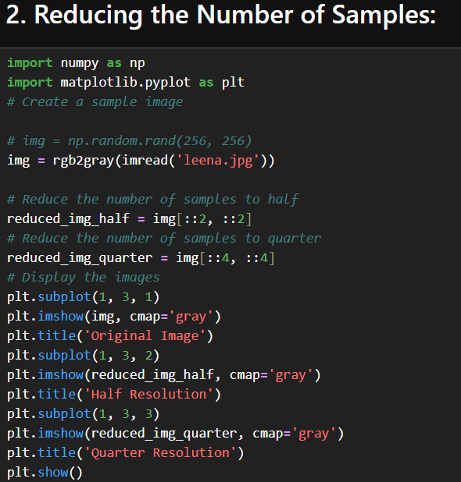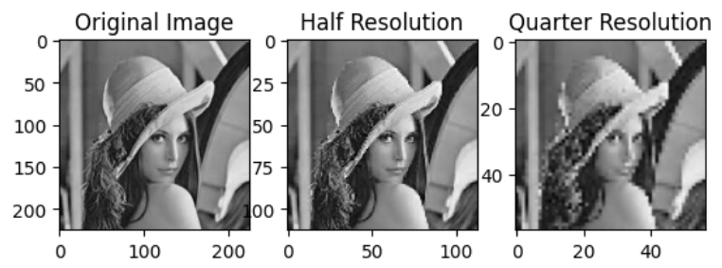
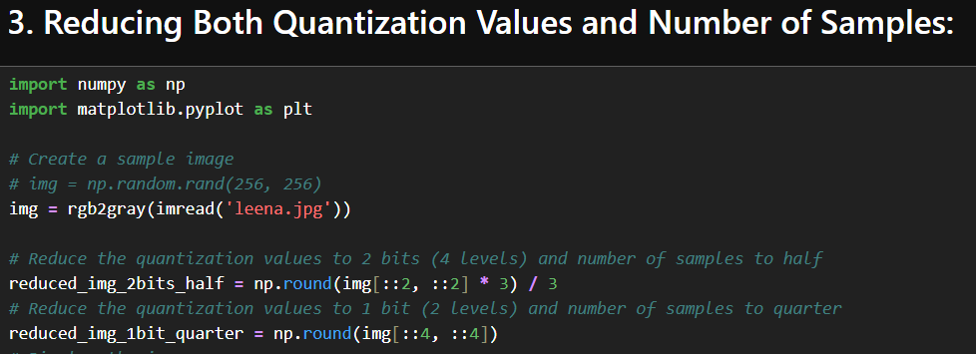
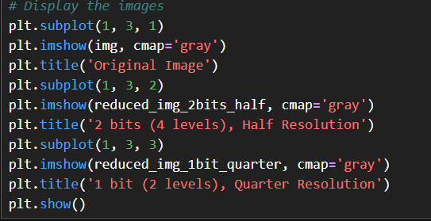
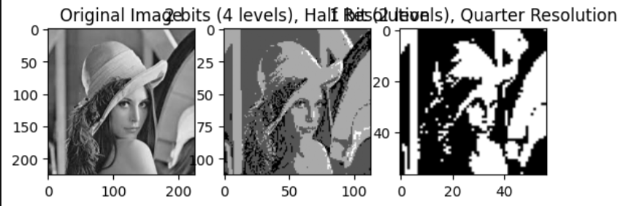
Conclusion: In conclusion, sampling and quantization convert a continuous image into a digital form by dividing it into pixels and assigning intensity values. This process makes images suitable for storage, processing, and analysis by computers.

